Lesson 1
Intentional Parent Video
What is an Intentional Parent?

What is the Safety Net & how do we build it?

Lesson 2
The Healing Formula Video
A. Using the Healing Formula

Component 1
Move Your Stuff
1.
2.
3.

Component 2
1.
2.
3.

Component 3
1.
2.
Component 4
1.
2.
3.
4.

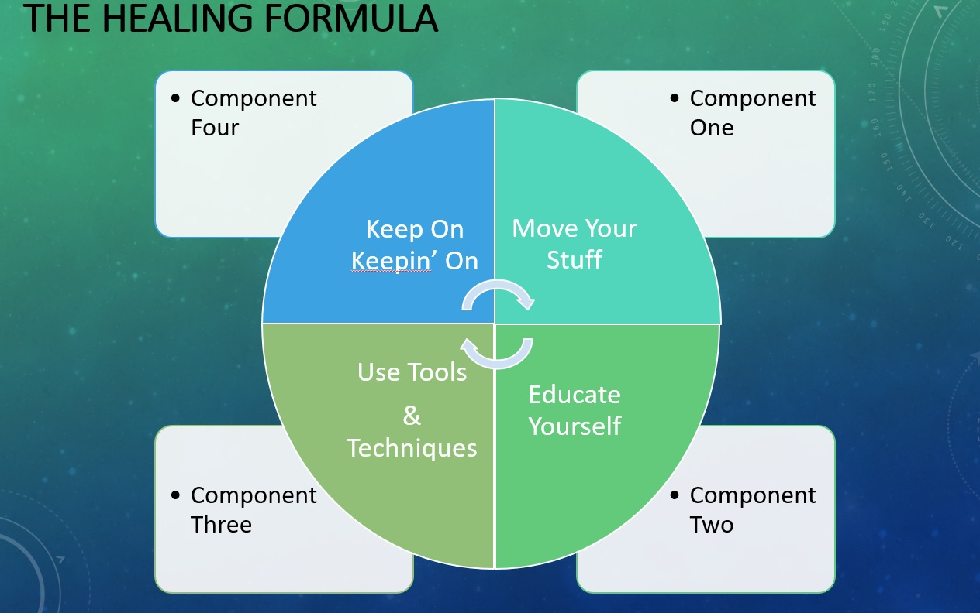

Lesson 3
Attachment Video

Important info in regards to Attachment.

Lesson 4
The Limbic System Video

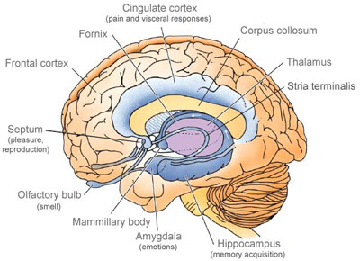

Lesson 5
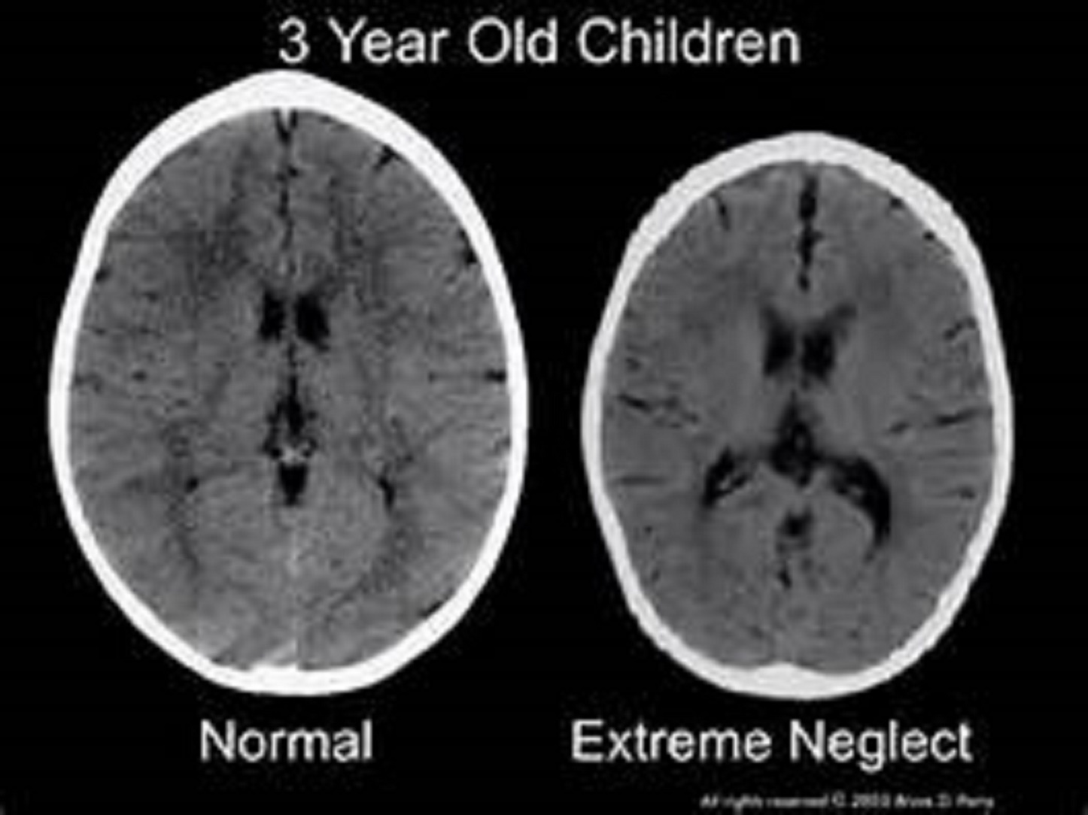

Brain Video

